**SPH3U: 3.4 Newton’s Third Law of Motion**

1. **Newton’s third law**

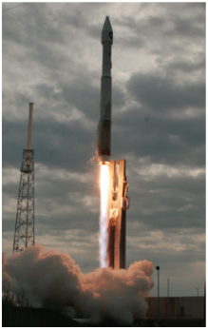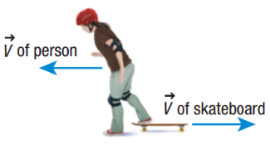

|  |  |
| --- | --- |
| Newton’s third law: |  |
| stepping off skateboard |  |
| rocket launch |  |

Explain each event in terms of Newton’s third law:

1. A swimmer moves through the water.
2. A small balloon releases air and flies around the classroom.
3. You start walking across the floor.
4. **Separate objects**

|  |  |
| --- | --- |
| Action and reaction force: |  |
| two FBDs |  |

Two skaters are standing on ice facing each other. Skater 1 pushes on skater 2 with a force of 70 N [E]. Assume that no friction actos on either skater. The mass of skater 1 is 50 kg and the mass of skater 2 is 70 kg.

1. State the action and reaction forces.
2. Draw the FBD of each skater.
3. Describe what will happen to each skater.
4. Calculate the acceleration of each skater.
5. **Summary**

**Homework:** page 141: #2-3, 6-9